**Phase 3: Data Modeling & Relationships**

This document outlines Phase 3 of the **Smart City Waste Management CRM Project**.  
In this phase, we design the **data model** — defining objects, fields, record types, layouts, and relationships.  
Spaces are provided to insert screenshots at each step.

**1. Standard & Custom Objects**

We created the following **Custom Objects**:

* **Pickup Request**
* **Truck**
* **Recycling Plant**

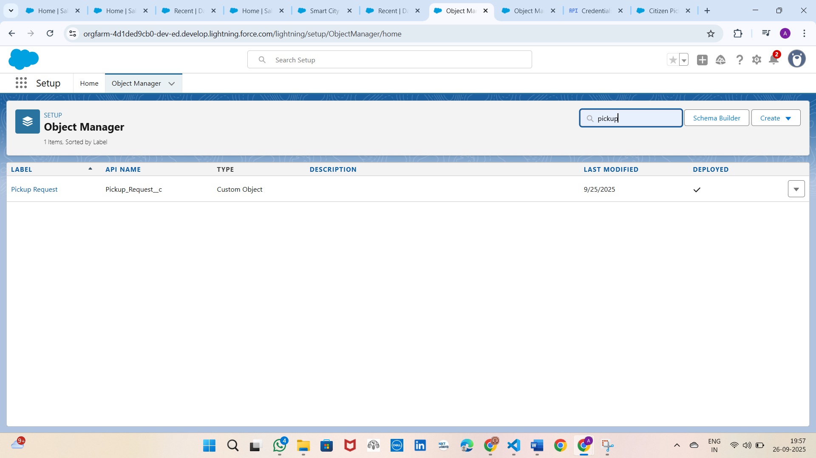

**2. Fields**

Defined fields for each object:

**Pickup Request**

* Request ID (Auto Number)
* Citizen (Lookup → User)
* Assigned Collector (Lookup → User)
* Recycling Plant (Lookup → Recycling Plant)
* Status (Picklist: New, Assigned, In Progress, Completed)
* Pickup Date/Time (DateTime)
* Address (Text)
* 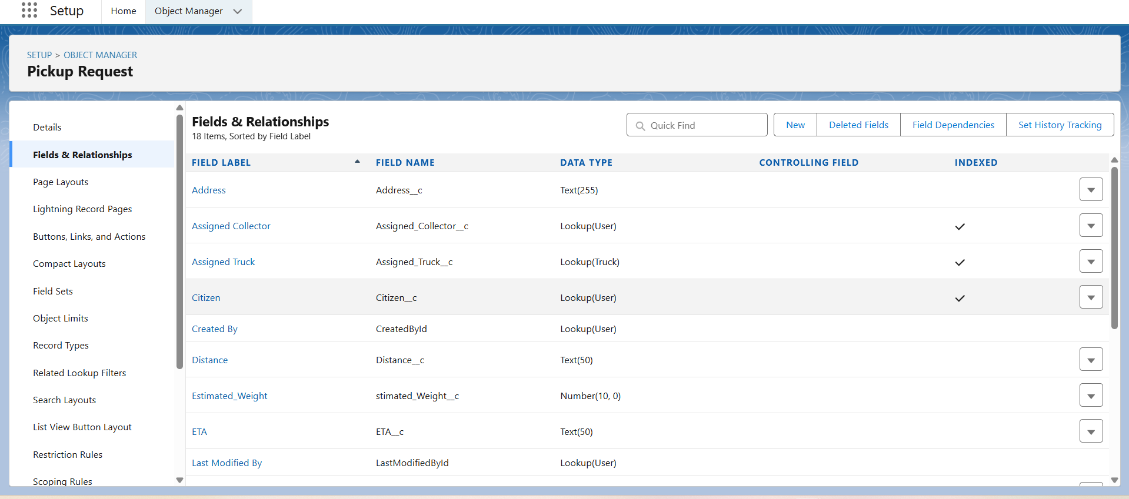

**Truck**

* Truck ID (Auto Number)
* Status (Picklist: Available, On Route, Maintenance)
* Assigned Collector (Lookup → User)
* Capacity (Number)
* Last Service Date (Date)

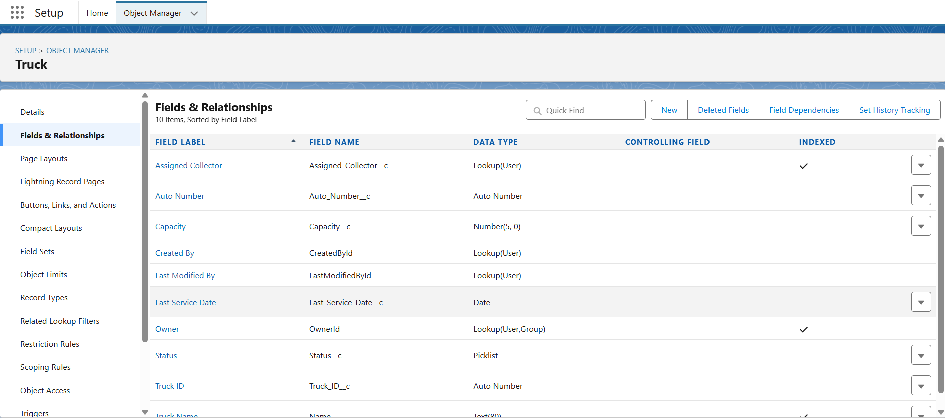

**Recycling Plant**

* Plant ID (Auto Number)
* Location (Text)
* Capacity (Number)
* Plant Admin (Lookup → User)

*.* 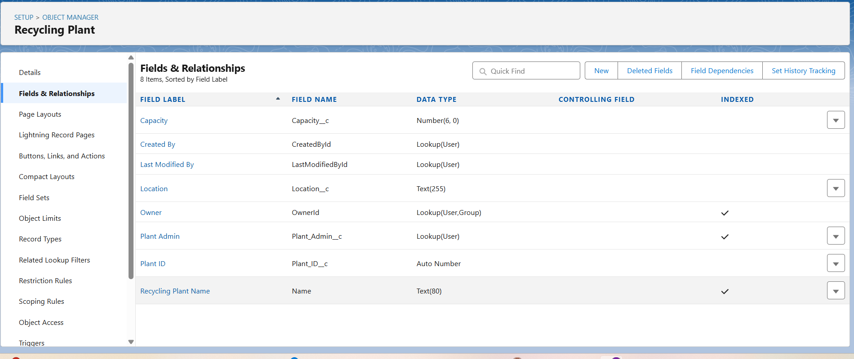

**3. Record Types**

Created **Record Types** for Pickup Request:

* **Citizen Request** (for Citizens)
* **Collector Handling** (for Collectors, Plant Admin, City Officials)

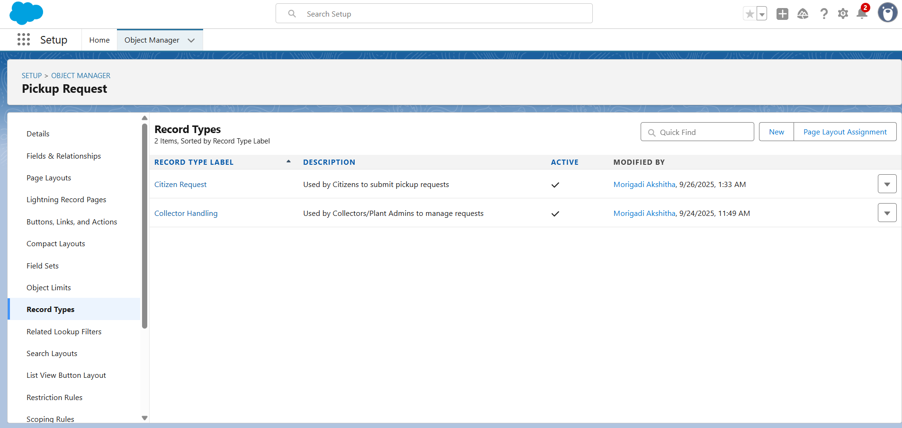

**4. Page Layouts**

Customized **Page Layouts**:

* **Citizen Request Layout** → Minimal fields for citizens (Pickup Date, Address).
* **Collector Handling Layout** → Full details for internal users (Assigned Collector, Recycling Plant, Status).

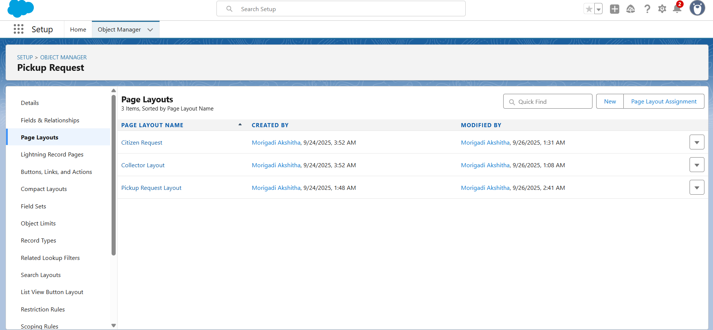**5. Compact Layouts**

Created **Compact Layouts** to improve Salesforce Mobile and record highlight panel.

Example (Pickup Request):

* Pickup Request Name
* Status
* Pickup Date/Time
* Address

**6. Schema Builder**

Used **Schema Builder** to visualize relationships:

* Pickup Request → Citizen (User)
* Pickup Request → Collector (User)
* Pickup Request → Recycling Plant
* Truck → Collector (User)